11. What to do in special situations
11.1 Using the lights (31)
1. Depending on the motor vehicle, how can you tell if the main beam is switched on? From the _____

2. You turn from a brightly lit road into an unlit road. What do you have to bear in mind?
3. A farm tractor is approaching you at dawn with its headlights switched on. What must you reckon with?
4. What can cause even dipped headlights to dazzle oncoming traffic?
5. While driving at night on a country road you see pedestrians on your side. What do you do if you are dazzled by an oncoming vehicle?
6. In the dark, an oncoming vehicle fails to dip its headlights. What can you do so that you can still see to a certain extent?
7. You are driving on a country road in darkness and rain and encounter oncoming vehicles with dipped headlights. What must you remember?
8. How can you tell whether the rear fog lamp is switched on?
9. Visibility is considerably reduced. When are you allowed to switch on fog headlamps?
10. You are driving at night on an unlit road. There is a motor vehicle travelling a short distance in front of you. Which lights must you have on?
11. When are you allowed to use fog headlamps also during the day?
12. When are you allowed to switch on rear fog lamps?
13. Where are parking lights sufficient when parking a car on unlit roads?
14. When you are driving, how can you tell whether the headlights are switched on full beam?
15. Which dangers can arise from a manual light range adjustment being incorrectly set?
16. Are you allowed to drive only with side lights (parking lights) in darkness?
17. When must you use dipped headlights also during the day?
18. In which cases must you at least switch on side lights (parking lights) in twilight or darkness?
19. What can be the cause of a rear light not to work?
20. You are driving in the dark with dipped headlights. Oncoming traffic flash their headlights at you. What can this mean?
21. What risks could arise if you drive with your main beam lights on?
22. Dazzling at night time on a rural road, you see persons on your side of the road. What do you do if you are dazzled by an oncoming vehicle?
23. The rear lighting systems of your car are covered. What has to be done? A luminaire rail system with all rear lighting systems _________
24. You are driving with main beam lights on in darkness. When do you have to dip your headlights?
25. You are driving with main beam lights on in darkness. When do you have to dip your headlights?
26. Why must you also drive with dipped headlight during the day when visibility is impaired by fog, rain or falling snow?
27. When do you have to switch on your dipped headlights?
28. What must you do in this situation when you are dazzled ?
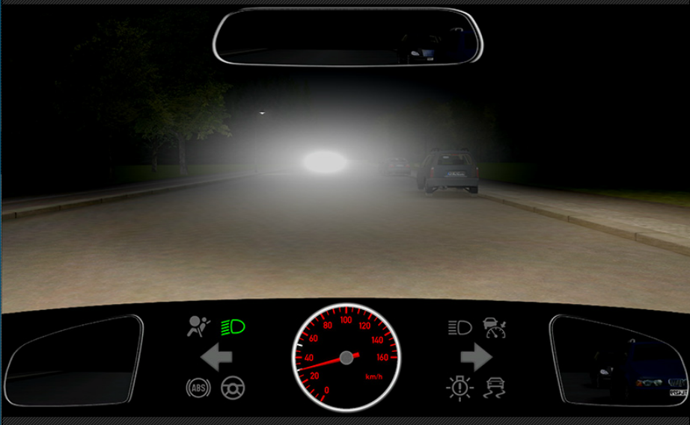
- If necessary, reduce your speed
- Look at the right-hand edge of the roadway
- Accelerate to get out of the beam of light more quickly
29. What must you be aware of here?
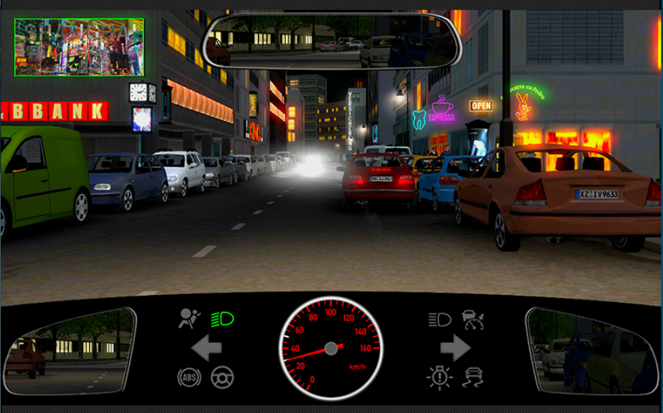
- That your vehicle will not be seen in time
- That you only detect oncoming vehicles after it is too late
- That the traffic lights are hardly distinct from the coloured signs
30. Why might driving along this road become dangerous?
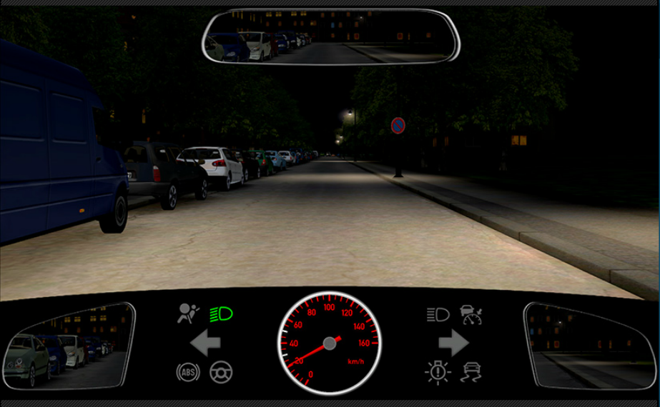
- Because poorly lit vehicles can be difficult to detect
- Because persons on the road can be easily overlooked
- Because oncoming vehicles will only be detected very late
31. Video – What must you be aware of? I may
- Turn on the rear fog lights
- Drive at 50 km/h maximum
- Drive at 80 km/h maximum
-----------------------------------------------------------------------------------------------------------------------------------------------------------
11.2 Tunnel (18)
1. What must you observe when you enter a tunnel?
- Drive with dipped headlights also during the day even in well lit tunnels
- Take off your sunglasses c) Switch fog headlamps on
2. What should you do when driving through a tunnel?
- In a tunnel with oncoming traffic, I position myself towards the right-hand edge of the roadway
- I memorise the safety features such as emergency exits and emergency telephones
- I drive with a reduced distance to the vehicle ahead, so that I can use its tail lights as guide
3. What must you do in case of a traffic jam in a tunnel?
- When traffic comes to a standstill, keep a safety distance of approximately 5m to the car ahead
- Switch hazard warning lights on
- Secure and leave vehicle immediately
4. What can impair your attention when driving through a tunnel?
- Reflections of light from oncoming traffic
- Length of the tunnel c) Good road markings
5. What must you observe particularly when driving through a tunnel?
- You may be distracted by light effects
- You may be distracted by very loud noise
- Signs for safety installations such as emergency exits and emergency telephones
6. Which basic code of conduct must you observe in a tunnel?
- Do not make a U-turn
- Follow instructions and information from the tunnel personnel
- Drive with dipped headlights also by day even in a well-lit tunnel
7. What do you do in a tunnel with oncoming traffic?
- Do not make a U-turn
- Do not drive over the lane boundary markings
- Drive over the lane boundary markings when overtaking
8. What do you do in case of a breakdown in a tunnel?
- If possible, park the vehicle in an emergency bay
- Switch on the hazard warning lights
- Let the engine run by way of precaution
9. You are driving in a tunnel and approach the end of a traffic jam. What do you do?
- Switch on the hazard warning lights
- Make a U-turn and leave the tunnel
- At the end of the traffic jam, switch off the engine and leave the vehicle
10. You notice an accident in the tunnel. What do you have to do?
- Inform emergency services via the SOS-telephone
- Switch on the hazard warning lights
- Do not leave your vehicle
11. There is a tunnel on my route. What should I know?
- I should know how I park and leave my vehicle if I am unable to continue driving
- I should know how escape routes are indicated in tunnels
- I can be sure that help will arrive promptly in the event of emergencies
12. While driving through a tunnel, you notice a fire in your vehicle. You are not able to exit the tunnel. What should you do? I bring the vehicle to a halt as far to the right-side of the roadway as possible or park it in an emergency lay-by and ________
- Switch off the engine
- Leave the key in the ignition
- Turn on the hazard warning system
13. While driving in a tunnel you were forced to bring your vehicle to a halt due to a fire. What should you do now?
- I trigger the fire alarm at the emergency call point
- I extinguish the fire as best I can
- I lock my vehicle
14. What does this traffic sign mean?
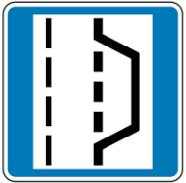
- In case of breakdown, you should stop in the emergency bay indicated
- There may be a vehicle in the next emergency bay
- You may stop here to have a break
15. During daylight, you enter a lit tunnel marked like this. What do you do?
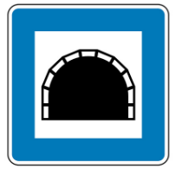
- I switch on the dipped headlights
- I do not have to switch on the lights c)I switch on the side lights
16. What do you have to do when you see this traffic sign?
- Take off your sunglasses
- Switch on dipped headlights c) Switch on the hazard warning lights
17. You drive into a brightly lit tunnel which is indicated like this. What do you do?
- Drive with dipped headlights
- Drive with daytime running lights c) Drive without lights
18. Video - I stop, switch off the engine and
- Exit the tunnel via the emergency exit
- Leave the ignition key or transponder behind when leaving the vehicle
- Wait in the vehicle for the scene of the accident to be cleared
-----------------------------------------------------------------------------------------------------------------------------------------------------------
11.3 How to deal with special vehicles (11)
1. A vehicle with flashing blue light and siren is approaching. What do you do?
- Clear the way for the vehicle
- Drive carefully onto the pavement if necessary
- At all events, brake hard and stop
2. You hear a siren. Which questions must you ask yourself?
- Could I obstruct the emergency vehicle?
- Where is the emergency vehicle coming from?
- Is the vehicle allowed to use a siren at all ?
3. What can a flashing amber light on a vehicle be a warning for?
- For an exceptionally wide vehicle
- For a large transport proceeding at low speed
- For dangers at roadworks or the scene of an accident
4. What does it mean when the flashing blue light of a vehicle is switched on but not the siren?
- Warning of fire-brigade in action
- Warning of an accident or other dangers
- A breakdown vehicle is on duty and on ist way to ist destination
5. What can a flashing blue light (without siren) mean?
- Advance warning of a closed convoy
- The vehicle is on duty. You should give way
- Without a siren, flashing blue light does not mean anything
6. A police signalling disc is displayed towards you from a vehicle driving in front of you. What does this mean?
- I may not overtake the vehicle
- I have to follow the vehicle until it stops
- I have to turn in the direction indicated
7. You are overtaken by a police vehicle, which pulls in immediately in front of you. The words „BITTE FOLGEN“ appear illuminated on the roof. What should you do? I have to ________
- Follow the police vehicle
- Stop if the police vehicle stops
- Allow the engine to continue running once I have stopped
8. You are overtaken by a police vehicle, which pulls in immediately in front of you. The words „BITTE FOLGEN“ appear illuminated on the roof. To whom does this apply?
- To me
9. The words „BITTE FOLGEN“ are illuminated on a police car immediately preceding your car. What does this mean?
- Only you must follow the police car
- Only heavy goods transports must follow the police car
- All cars driving in the same direction must follow the police car
10. In your rear-view mirror, you see the words „STOP POLIZEI“ in red illuminated letters on the roof of a police car immediately behind your car. What does this apply for?
- To you only
11. Video - You are being followed by an ambulance with its blue lights flashing and siren sounding. What should you do?
- I move out of the way immediately without endangering others
- I make way immediately once the traffic light has turned green
- I prompt the driver of the vehicle beside me to make way
-----------------------------------------------------------------------------------------------------------------------------------------------------------

11.4 What to do in case of an accident (24)
1. Under what emergency numbers can you call the police and the emergency services in Germany?
- 110
- 112
- 115
2. What should you do, if it is no longer possible to avoid a collision with wild animals?
- I brake as hard as possible
- I maintain my direction of movement
- I always take an evasive movement
3. You are involved in an accident. What document must you present to the other person involved in the accident, if required?
- My driving license
- The registeration certificate Part 1 or the operating permit
- The liability insurance contract
4. You experience a breakdown outside of a built-up area. Your motor vehicle is located on the carriageway behind a bend in the road. What is the right course of action in this situation?
- I should wear a high-visibility vest
- I have to turn on my hazard warning lights
- I must at least position a conspicious warning sign behind the vehicle
5. How could a dangerous situation arise?
- Through failure to maintain suitable speed
- Through vehicles at a standstill
- By having lights turned on during day
6. You are driving on a new road through a woodland area. What must you reckon with?
- Game animals unexpectedly crossing the roadway
- An obstruction caused by an accident involving a game animal
- There is no reason to expect accidents involving game animals on new roads
7. Several deer run across the road in front of your vehicle. What must you reckon with?
- The herd may come back and cross the road again
- There could be stragglers following the herd
- There is no reason to expect any more animals
8. At which time of the day do you have to reckon with increased game pass?
- At dawn
- At dusk
- At noon
9. You have damaged a parked vehicle. Though you have waited for a reasonable length of time, the injured party has not appeared. What must you do?
- Leave your name and address on the damaged vehicle and immediately report the accident to the police
- It is sufficient to give your name and address to a witness who was not involved
- You may leave the scene of the accident without taking further action
10. You are the first person to arrive at the scene of an accident with injured persons. In which order do you proceed
- Make the scene of the accident safe – give first aid – call the rescue service
- Call the rescue service – make the scene of the accident safe – Give first aid
- Give first aid – call the rescue service – give first aid
11. You are the first person to arrive at the scene of an accident with injured persons. What should you do first as rule?
- Make the scene of the accident safe
- Check the seriousness of the injuries
- Drive to the next telephone box and call the rescue service
12. How can you get help on an autobahn?
- Dial 112 or 110
- Use an emergency call box
- From the autobahn service areas
13. What must you do if game animals suddenly appear in the full beam of your headlights?
- Immediately dip your headlights
- Sound the horn and brake
- Proceed on full beam
14. What must you do after an accident with a game animal (for example a deer)?
- Stop, switch on hazard warning lights and make the scene of the accident safe
- Inform the police or the nearest forestry office
- Proceed without stopping
15. At what distance must the warning triangle be placed when a car has broken down on a road with fast-moving traffic?
- At a distance of around 100 m
- At a distance of around 50 m
- At a distance of around 10 m
16. At night, how must you secure a vehicle which has broken down at a place where it constitutes a danger to other traffic?
- Place a warning triangle at a sufficient distance
- Immediately switch on the hazard warning lights
- Switch on the reversing lights
17. When must you switch on the hazard warning lights?
- When your vehicle has broken down at a place where it cannot readily be recognized as a stationary obstruction
- For all loading or unloading
- When double-parking
18. You are driving quickly along a main road and some distance ahead you see a deer close to the carriageway. What should you do? I have to _________
- Reduce speed
- Be ready to brake
- Perform an emergency braking manoeuvre
19. You are involved in a traffic accident. What are you obliged to do? I have to ____
- Reduce speed
- Be ready to brake
- Perform an emergency braking manoeuvre
20. You have an accident on a rural road. How do you secure the scene of the accident site?
- I turn on my hazard warning lights immediately
- If necessary, I warn other vehicles using hand signals
- I set up the warning triangle in a well-visible position about 100 m from the scene of the accident
21. What are you obliged to do, if you are involved in a road traffic accident? I have to ____
- Secure the scene of the accident
- Provide aid if anyone has been injured
- Stop and determine the consequences of the accident
22. Video - What is the right course of action in this situation?
- I continue driving as before
- I brake hard immediately
- I take a photograph of the scene of the accident
23. Video - What should you do now?
- I perform an emergency braking manoeuvre
- I hold the steering wheel straight and firmly
- I steer to the left
24. Video - What is the right course of action now?
- I keep a tight hold of the steering wheel and keep it pointed straight ahead
- I swerve to the right
- I swerve to the left
-----------------------------------------------------------------------------------------------------------------------------------------------------------
11.5 Towing and Hauling (7)
1. You want to tow another vehicle with your car. What must you know?
- You must atleast have a driving permit class B
- You must atleast have a driving permit class BE
2. A car with servo brakes has broken down with engine damage. What is correct when towing the car away?
- If possible, use a tow-bar
- The car being towed can only achieve slight braking effect even when increased pressure is applied to the pedal
- The action of the foot brake is not impaired by the engine not running
3. A car with power steering has broken down with engine damage and must be towed away. What is correct ? The steering of the broken down car ________
- Is considerably heavier
- Is not impaired
- Is locked
4. What must you remember when towing?
- Tow-rope/Tow-bat must be clearly marked
- The distance between the vehicles must not exceed 5 m
- Motorcycle may only be towed with a fixed connection
5. Your vehicle has broken down on the autobahn. What must you remember when having it towed away?
- You must leave the autobahn at the next exit
- During towing, both vehicles must have their hazard warning lights switched on
- You may continue along the autobahn to the exit nearest a suitable garage
6. You car has a fault and can no longer be driven. What must you be aware of during towing? During towing
- A towing bar should be used where possible
- The force required to operate the brake pedal is significantly greater if the engine has failed
- The rear fog lights should also be switched on to indicate the towing procedure
7. You car has a fault and can no longer be driven. What must you be aware of during towing? During towing
- The towing cable should be kept as taut as possible
- The hazard lights must be switched on on both vehicles
- The motorway may only be used to shorten the journey to the next car garage
-----------------------------------------------------------------------------------------------------------------------------------------------------------
11.6 Warning signs (7)
1. What do hazard warning lights draw your attention to?
- To a traffic congestion
- To vehicles which have broken down
- To school buses with children boarding or alighting
2. What must you reckon with when you see a hazard warning lights flash? With
- A car being towed
- A truck broken down
- A school bus with children alighting
3. For which purposes is a horn allowed to be used outside built-up areas?
- As a warning signal
- As an overtaking signal
- As a calling signal
4. For which purposes is a horn allowed to be used in built-up areas?
- As a warning signal
- As an overtaking signal
- As a calling signal
5. Where is it permitted to flash headlights to indicate your intention to overtake?
- In daylight outside built-up areas
- In darkness outside built-up areas
- In darkness in built-up areas
6. What can prevent you from hearing warning signals?
- Using headphones
- The exhaust being too loud
- Having the radio on too loud
7. If the horn does not work, what can be the reason?
- The horn’s operating device is defective
- Blown Fuse
- Defective starter
-----------------------------------------------------------------------------------------------------------------------------------------------------------

